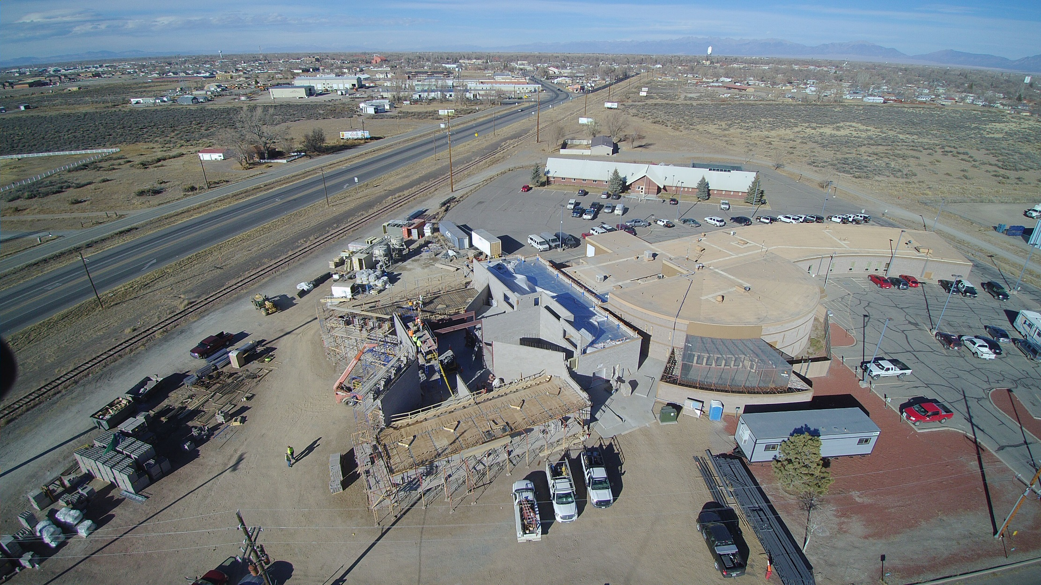

**Project: Alamosa County Justice Center**

**Category: Government**

**Client: Alamosa County**

**Completed: 2018**

**Value:**